Egg Harbor Township HS
FBLA Club

13th ANNUAL

ULTIMATE
NERFBALL TOURNAMENT
01.04.19
REGISTRATION PACKET
Make up date: February 1, 2019
Includes:

1 Team Registration Form
1 List of Rules and Expectations
1 Team Captain Agreement
1 Team Name/Team Shirt Design Approval Form
10 Player Permission Slips

Packets will be accepted on a first come, first serve basis.

PACKET MUST BE COMPLETE WITH THE FULL PAYMENT FOR ALL PARTICIPANTS

Return completed packets to:
Mrs. Duff – Room B123

DEADLINE FOR COMPLETED PACKETS – Friday, December 14, 2018

*Additional forms are available on the website -
http://ehtfbla.com
ULTIMATE NERFBALL TOURNAMENT

TEAM REGISTRATION PACKET
01.04.19 6:00 P.M. – 11:00 P.M.
10 Players per team
$120 TEAM REGISTRATION FEE--regardless of number of competitors
($12 suggested fee per competitor)
A pretzel & beverage coupon will be provided for all team players.
Team Name: ___________________________________________________________

Name E-mail Address Phone Number
(Captain)
1.
2.
3.
4.
5.
6.
7.
8.
9.
10.
- This sheet must be returned along with 10 Permission Slips and the $12 per competitor fee to
Mrs. Duff in Room B123. Signups are on a first come, first serve basis. The LAST day of registration is Friday, December 14, 2018!
- Prizes may be awarded to Grand Champions, Best Dressed, Best Sportsmanship, Best Team Spirit and other categories. Prizes and prize categories to be determined by tournament administrators.
- All competitors must report to the gymnasium by 5:00pm on evening of event for registration and further instruction.
Dress Code: You are encouraged to wear coordinated “uniforms.” You may wear whatever clothing you want WITHIN school dress code rules. Sneakers are required for competitors.

**Team Name and Uniform Design must be appropriate to school
and are subject to approval by EHTHS Administration**
EHTHS FBLA Ultimate Nerfball
Team Captain Agreement

The FBLA Ultimate Nerfball Challenge will be held on January 4, 2019, in an effort to support the March of Dimes and the Egg Harbor Township High School FBLA club.

Teams must consist of a maximum of ten players. Teams may have any ratio of girls to guys. Team must submit registration fees and completed team packets to Mrs. Duff in room B123 by December 14, 2018. Teams must be half filled with EHTHS students (No one under 9th grade)

Complete the information below and return it as part of a completed team registration packet.

EMERGENCY CONTACT NUMBERS ARE MANDATORY!
Thank you, and see you on the court!

Team Name: ___________________________
Captain: ____________________ Emer. Contact #______________
Member 2: ___________________ Emer. Contact #______________
Member 3: ___________________ Emer. Contact #______________
Member 4: ___________________ Emer. Contact #______________
Member 5: ___________________ Emer. Contact #______________
Member 6: ___________________ Emer. Contact #______________
Member 7: ___________________ Emer. Contact #______________
Member 8: ___________________ Emer. Contact #______________
Member 9: ___________________ Emer. Contact #______________
Member 10: ___________________ Emer. Contact #______________

In case of inclement weather and rescheduling of tournament:
FBLA will contact the team captain ONLY as soon as possible.
Team captains are required to contact all team members.

Team Captain's Agreement Statement:

I, as captain of my team, have read and understood the rules in the registration packet and agree to comply with all rules for the duration of the Ultimate Nerfball Tournament. I have also made the rules clear to my teammates and made sure that they are in agreement with all rules for the duration of the Ultimate Nerfball Tournament. I am aware that I am responsible for team members that are not part of EHTHS.

I will be present for the mandatory Captain’s meeting on Thursday, JANUARY 3, 2019 in room B123.

Captain's Signature: Captain’s Parent/Guardian Signature:

____________________________________ ____________________________________
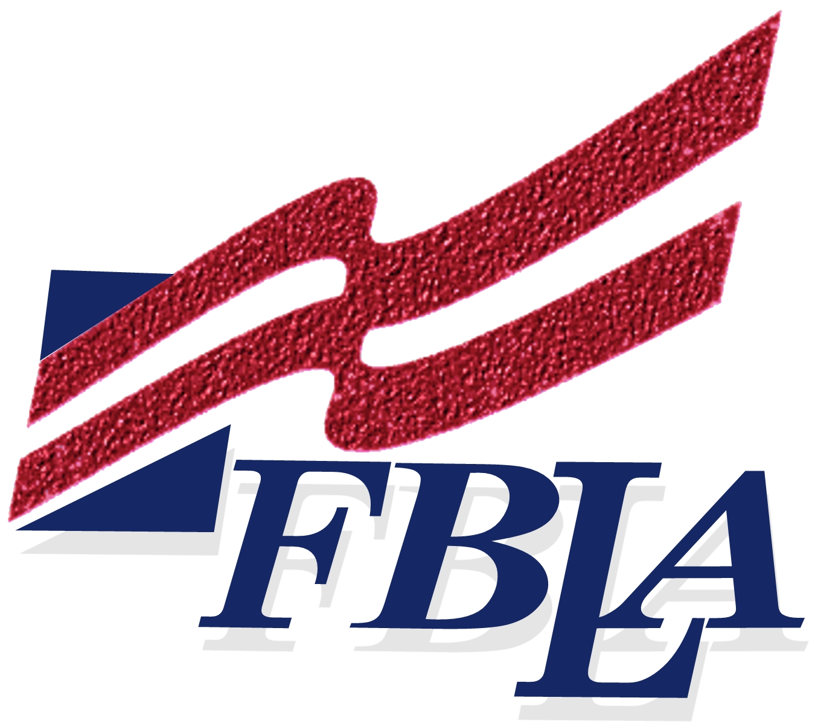
ULTIMATE NERFBALL TOURNAMENT
TEAM NAME/SHIRT DESIGN APPROVAL

Team name and Team shirt design or costume MUST be in compliance with the EHTHS Student Handbook and approved by EHTHS Administration.
Team Name:
1st Choice _____________________________________________________
2nd Choice_____________________________________________________
Team Shirt Design/Costume Description:
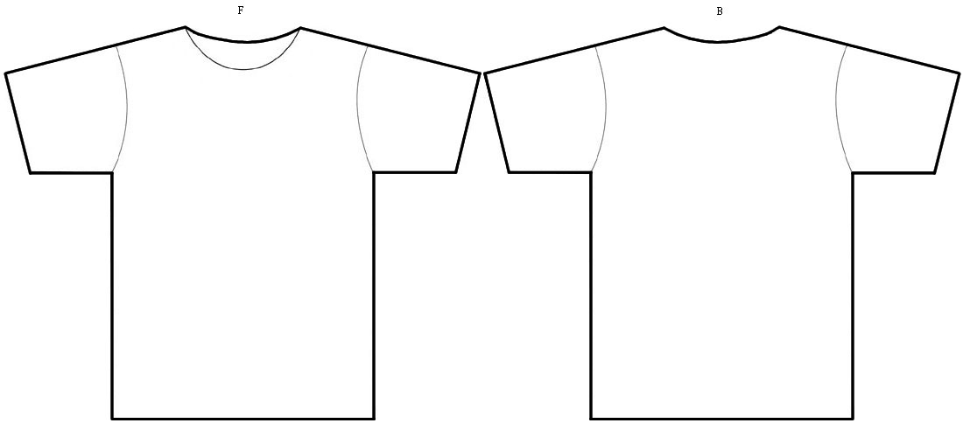
Draw the front and back of the team shirt design for the event OR provide a detailed description of the costume the team plans the night of the event. Each shirt must be numbered 1 through 10.

EHTHS Approved________________________________________________Date____________
Approved team name and shirt/costume designs are FINAL
Failure to comply will result in team disqualification

Ultimate Nerfball Tournament Permission Slip
Students under the age of 18 must have a parent/guardian signature
However, all players must be in at least 9th grade. Teams must consist of half the team being EHTHS students.

Egg Harbor Township High School will be hosting the
FBLA 13th Annual Ultimate Nerfball Tournament
January 4th, 2019
6:00pm – 11:00pm

Teams of 10 players will compete in a triple elimination bracket. **Teams will represent
EHT student body, EHT residents, and employees and faculty of EHT BOE and Egg Harbor Township** Identification MUST be provided at event check-in as proof of above requirement.

Name:_____________________________________________D.O.B_________________

Address:________________________________________________________________

City:_______________________________ State:________________ Zip:___________

Telephone Number:_____________________ E-mail Address:___________________

Team Name:______________________________________________ Grade:________

TEAM REGISTRATION FEE IS $120. Make checks payable to Egg Harbor Township High School FBLA Club. Registration proceeds are a donation to the March of Dimes and EHTHS FBLA. Participants will receive one complimentary pretzel and one complimentary drink during the tournament.

I, the undersigned, individually or as a parent(s) and / or guardian(s) of the individual listed above ask that he/she be admitted to participate in this sport competition. In association of such admission, I do hereby release, discharge, and hold harmless the EHT school district, any participating charities or trade associations, and all officers, agents, volunteers, sponsors and employees of and from all causes, liabilities, damages, claims, or demands whatsoever on account of any injury or accident involving the said individual attendance at the sport competition and/or activities held in connection with the event.

_______________________________ _______________________________________
(Student Signature) (Parent/Guardian/Resident Signature)

_______________________________________
(Parent/Guardian/Resident Contact Number)

*Players MUST report to the school by 5:00 PM on January 4, 2019 to sign in.
*Players MUST present proper ID as verification of residency or employment in EHT at check-in on night of event to receive a participant bracelet.
*Players MUST wear sneakers (no black soles permitted) and are encouraged to wear team uniforms. Protective goggles are not available.

PLEASE RETURN THIS FORM TO MRS. DUFF IN ROOM B123 AS PART OF THE TEAM REGISTRATION PACKET BY FRIDAY, DECEMBER 14, 2018.

Ultimate Nerfball Tournament Permission Slip
Students under the age of 18 must have a parent/guardian signature
However, all players must be in at least 9th grade. Teams must consist of half the team being EHTHS students.

Egg Harbor Township High School will be hosting the
FBLA 13th Annual Ultimate Nerfball Tournament
JANUARY 4TH, 2019
6:00pm – 11:00pm

Teams of 10 players will compete in a triple elimination bracket. **Teams will represent
EHT student body, EHT residents, and employees and faculty of EHT BOE and Egg Harbor Township** Identification MUST be provided at event check-in as proof of above requirement.

Name:_____________________________________________D.O.B_________________

Address:________________________________________________________________

City:_______________________________ State:________________ Zip:___________

Telephone Number:_____________________ E-mail Address:___________________

Team Name:______________________________________________ Grade:________

TEAM REGISTRATION FEE IS $120. Make checks payable to Egg Harbor Township High School FBLA Club. Registration proceeds are a donation to the March of Dimes and EHTHS FBLA. Participants will receive one complimentary pretzel and one complimentary drink during the tournament.

I, the undersigned, individually or as a parent(s) and / or guardian(s) of the individual listed above ask that he/she be admitted to participate in this sport competition. In association of such admission, I do hereby release, discharge, and hold harmless the EHT school district, any participating charities or trade associations, and all officers, agents, volunteers, sponsors and employees of and from all causes, liabilities, damages, claims, or demands whatsoever on account of any injury or accident involving the said individual attendance at the sport competition and/or activities held in connection with the event.

_______________________________ _______________________________________
(Student Signature) (Parent/Guardian/Resident Signature)

_______________________________________
(Parent/Guardian/Resident Contact Number)

*Players MUST report to the school by 5:00 PM on January 4, 2019 to sign in.
*Players MUST present proper ID as verification of residency or employment in EHT at check-in on night of event to receive a participant bracelet.
*Players MUST wear sneakers (no black soles permitted) and are encouraged to wear team uniforms. Protective goggles are not available.

PLEASE RETURN THIS FORM TO MRS. DUFF IN ROOM B123 AS PART OF THE TEAM REGISTRATION PACKET BY FRIDAY, DECEMBER 14, 2018.

Ultimate Nerfball Tournament Permission Slip
Students under the age of 18 must have a parent/guardian signature
However, all players must be in at least 9th grade.Teams must consist of half the team being EHTHS students.

Egg Harbor Township High School will be hosting the
FBLA 13th Annual Ultimate Nerfball Tournament
January 4, 2018
6:00pm – 11:00pm

Teams of 10 players will compete in a triple elimination bracket. **Teams will represent
EHT student body, EHT residents, and employees and faculty of EHT BOE and Egg Harbor Township** Identification MUST be provided at event check-in as proof of above requirement.

Name:_____________________________________________D.O.B_________________

Address:________________________________________________________________

City:_______________________________ State:________________ Zip:___________

Telephone Number:_____________________ E-mail Address:___________________

Team Name:______________________________________________ Grade:________

TEAM REGISTRATION FEE IS $120. Make checks payable to Egg Harbor Township High School FBLA Club. Registration proceeds are a donation to the March of Dimes and EHTHS FBLA. Participants will receive one complimentary pretzel and one complimentary drink during the tournament.

I, the undersigned, individually or as a parent(s) and / or guardian(s) of the individual listed above ask that he/she be admitted to participate in this sport competition. In association of such admission, I do hereby release, discharge, and hold harmless the EHT school district, any participating charities or trade associations, and all officers, agents, volunteers, sponsors and employees of and from all causes, liabilities, damages, claims, or demands whatsoever on account of any injury or accident involving the said individual attendance at the sport competition and/or activities held in connection with the event.

_______________________________ _______________________________________
(Student Signature) (Parent/Guardian/Resident Signature)

_______________________________________
(Parent/Guardian/Resident Contact Number)

*Players MUST report to the school by 5:00 PM on January 4, 2019 to sign in.
*Players MUST present proper ID as verification of residency or employment in EHT at check-in on night of event to receive a participant bracelet.
*Players MUST wear sneakers (no black soles permitted) and are encouraged to wear team uniforms. Protective goggles are not available.

PLEASE RETURN THIS FORM TO MRS. DUFF IN ROOM B123 AS PART OF THE TEAM REGISTRATION PACKET BY FRIDAY, DECEMBER 14, 2018.

Ultimate Nerfball Tournament Permission Slip
Students under the age of 18 must have a parent/guardian signature
However, all players must be in at least 9th grade.Teams must consist of half the team being EHTHS students.

Egg Harbor Township High School will be hosting the
FBLA 13th Annual Ultimate Nerfball Tournament
January 4th, 2019
6:00pm – 11:00pm

Teams of 10 players will compete in a triple elimination bracket. **Teams will represent
EHT student body, EHT residents, and employees and faculty of EHT BOE and Egg Harbor Township** Identification MUST be provided at event check-in as proof of above requirement.

Name:_____________________________________________D.O.B_________________

Address:________________________________________________________________

City:_______________________________ State:________________ Zip:___________

Telephone Number:_____________________ E-mail Address:___________________

Team Name:______________________________________________ Grade:________

TEAM REGISTRATION FEE IS $120. Make checks payable to Egg Harbor Township High School FBLA Club. Registration proceeds are a donation to the March of Dimes and EHTHS FBLA. Participants will receive one complimentary pretzel and one complimentary drink during the tournament.

I, the undersigned, individually or as a parent(s) and / or guardian(s) of the individual listed above ask that he/she be admitted to participate in this sport competition. In association of such admission, I do hereby release, discharge, and hold harmless the EHT school district, any participating charities or trade associations, and all officers, agents, volunteers, sponsors and employees of and from all causes, liabilities, damages, claims, or demands whatsoever on account of any injury or accident involving the said individual attendance at the sport competition and/or activities held in connection with the event.

_______________________________ _______________________________________
(Student Signature) (Parent/Guardian/Resident Signature)

_______________________________________
(Parent/Guardian/Resident Contact Number)

*Players MUST report to the school by 5:00 PM on January 4, 2019 to sign in.
*Players MUST present proper ID as verification of residency or employment in EHT at check-in on night of event to receive a participant bracelet.
*Players MUST wear sneakers (no black soles permitted) and are encouraged to wear team uniforms. Protective goggles are not available.

PLEASE RETURN THIS FORM TO MRS. DUFF IN ROOM B123 AS PART OF THE TEAM REGISTRATION PACKET BY FRIDAY DECEMBER 14, 2018.

Ultimate Nerfball Tournament Permission Slip
Students under the age of 18 must have a parent/guardian signature
However, all players must be in at least 9th grade.Teams must consist of half the team being EHTHS students.

Egg Harbor Township High School will be hosting the
FBLA 13th Annual Ultimate Nerfball Tournament
January 4^{thd}, 2019
6:00pm – 11:00pm

Teams of 10 players will compete in a triple elimination bracket. **Teams will represent
EHT student body, EHT residents, and employees and faculty of EHT BOE and Egg Harbor Township** Identification MUST be provided at event check-in as proof of above requirement.

Name:_____________________________________________D.O.B_________________

Address:________________________________________________________________

City:_______________________________ State:________________ Zip:___________

Telephone Number:_____________________ E-mail Address:___________________

Team Name:______________________________________________ Grade:________

TEAM REGISTRATION FEE IS $120. Make checks payable to Egg Harbor Township High School FBLA Club. Registration proceeds are a donation to the March of Dimes and EHTHS FBLA. Participants will receive one complimentary pretzel and one complimentary drink during the tournament.

I, the undersigned, individually or as a parent(s) and / or guardian(s) of the individual listed above ask that he/she be admitted to participate in this sport competition. In association of such admission, I do hereby release, discharge, and hold harmless the EHT school district, any participating charities or trade associations, and all officers, agents, volunteers, sponsors and employees of and from all causes, liabilities, damages, claims, or demands whatsoever on account of any injury or accident involving the said individual attendance at the sport competition and/or activities held in connection with the event.

_______________________________ _______________________________________
(Student Signature) (Parent/Guardian/Resident Signature)

_______________________________________
(Parent/Guardian/Resident Contact Number)

*Players MUST report to the school by 5:00 PM on January 4th 2019 to sign in.
*Players MUST present proper ID as verification of residency or employment in EHT at check-in on night of event to receive a participant bracelet.
*Players MUST wear sneakers (no black soles permitted) and are encouraged to wear team uniforms. Protective goggles are not available.

PLEASE RETURN THIS FORM TO MRS. DUFF IN ROOM B123 AS PART OF THE TEAM REGISTRATION PACKET BY FRIDAY, DECEMBER 14, 2018.

Ultimate Nerfball Tournament Permission Slip
Students under the age of 18 must have a parent/guardian signature
However, all players must be in at least 9th grade. Teams must consist of half the team being EHTHS students.

Egg Harbor Township High School will be hosting the
FBLA 13th Annual Ultimate Nerfball Tournament
January 4th, 2019
6:00pm – 11:00pm

Teams of 10 players will compete in a triple elimination bracket. **Teams will represent
EHT student body, EHT residents, and employees and faculty of EHT BOE and Egg Harbor Township** Identification MUST be provided at event check-in as proof of above requirement.

Name:_____________________________________________D.O.B_________________

Address:________________________________________________________________

City:_______________________________ State:________________ Zip:___________

Telephone Number:_____________________ E-mail Address:___________________

Team Name:______________________________________________ Grade:________

TEAM REGISTRATION FEE IS $120. Make checks payable to Egg Harbor Township High School FBLA Club. Registration proceeds are a donation to the March of Dimes and EHTHS FBLA. Participants will receive one complimentary pretzel and one complimentary drink during the tournament.

I, the undersigned, individually or as a parent(s) and / or guardian(s) of the individual listed above ask that he/she be admitted to participate in this sport competition. In association of such admission, I do hereby release, discharge, and hold harmless the EHT school district, any participating charities or trade associations, and all officers, agents, volunteers, sponsors and employees of and from all causes, liabilities, damages, claims, or demands whatsoever on account of any injury or accident involving the said individual attendance at the sport competition and/or activities held in connection with the event.

_______________________________ _______________________________________
(Student Signature) (Parent/Guardian/Resident Signature)

_______________________________________
(Parent/Guardian/Resident Contact Number)

*Players MUST report to the school by 5:00 PM on January 4, 2019 to sign in.
*Players MUST present proper ID as verification of residency or employment in EHT at check-in on night of event to receive a participant bracelet.
*Players MUST wear sneakers (no black soles permitted) and are encouraged to wear team uniforms. Protective goggles are not available.

PLEASE RETURN THIS FORM TO MRS. DUFF IN ROOM B123 AS PART OF THE TEAM REGISTRATION PACKET BY FRIDAY, DECEMBER 14, 2018.

Ultimate Nerfball Tournament Permission Slip
Students under the age of 18 must have a parent/guardian signature
However, all players must be in at least 9th grade.Teams must consist of half the team being EHTHS students.

Egg Harbor Township High School will be hosting the
FBLA 13th Annual Ultimate Nerfball Tournament
January 4th, 2019
6:00pm – 11:00pm

Teams of 10 players will compete in a triple elimination bracket. **Teams will represent
EHT student body, EHT residents, and employees and faculty of EHT BOE and Egg Harbor Township** Identification MUST be provided at event check-in as proof of above requirement.

Name:_____________________________________________D.O.B_________________

Address:________________________________________________________________

City:_______________________________ State:________________ Zip:___________

Telephone Number:_____________________ E-mail Address:___________________

Team Name:______________________________________________ Grade:________

TEAM REGISTRATION FEE IS $120. Make checks payable to Egg Harbor Township High School FBLA Club. Registration proceeds are a donation to the March of Dimes and EHTHS FBLA. Participants will receive one complimentary pretzel and one complimentary drink during the tournament.

I, the undersigned, individually or as a parent(s) and / or guardian(s) of the individual listed above ask that he/she be admitted to participate in this sport competition. In association of such admission, I do hereby release, discharge, and hold harmless the EHT school district, any participating charities or trade associations, and all officers, agents, volunteers, sponsors and employees of and from all causes, liabilities, damages, claims, or demands whatsoever on account of any injury or accident involving the said individual attendance at the sport competition and/or activities held in connection with the event.

_______________________________ _______________________________________
(Student Signature) (Parent/Guardian/Resident Signature)

_______________________________________
(Parent/Guardian/Resident Contact Number)

*Players MUST report to the school by 5:00 PM on January 4, 2019 to sign in.
*Players MUST present proper ID as verification of residency or employment in EHT at check-in on night of event to receive a participant bracelet.
*Players MUST wear sneakers (no black soles permitted) and are encouraged to wear team uniforms. Protective goggles are not available.

PLEASE RETURN THIS FORM TO MRS. DUFF IN ROOM B123 AS PART OF THE TEAM REGISTRATION PACKET BY FRIDAY, DECEMBER 14, 2018.

Ultimate Nerfball Tournament Permission Slip
Students under the age of 18 must have a parent/guardian signature
However, all players must be in at least 9th grade.Teams must consist of half the team being EHTHS students.

Egg Harbor Township High School will be hosting the
FBLA 13th Annual Ultimate Nerfball Tournament
January 4th, 2019
6:00pm – 11:00pm

Teams of 10 players will compete in a triple elimination bracket. **Teams will represent
EHT student body, EHT residents, and employees and faculty of EHT BOE and Egg Harbor Township** Identification MUST be provided at event check-in as proof of above requirement.

Name:_____________________________________________D.O.B_________________

Address:________________________________________________________________

City:_______________________________ State:________________ Zip:___________

Telephone Number:_____________________ E-mail Address:___________________

Team Name:______________________________________________ Grade:________

TEAM REGISTRATION FEE IS $120. Make checks payable to Egg Harbor Township High School FBLA Club. Registration proceeds are a donation to the March of Dimes and EHTHS FBLA. Participants will receive one complimentary pretzel and one complimentary drink during the tournament.

I, the undersigned, individually or as a parent(s) and / or guardian(s) of the individual listed above ask that he/she be admitted to participate in this sport competition. In association of such admission, I do hereby release, discharge, and hold harmless the EHT school district, any participating charities or trade associations, and all officers, agents, volunteers, sponsors and employees of and from all causes, liabilities, damages, claims, or demands whatsoever on account of any injury or accident involving the said individual attendance at the sport competition and/or activities held in connection with the event.

_______________________________ _______________________________________
(Student Signature) (Parent/Guardian/Resident Signature)

_______________________________________
(Parent/Guardian/Resident Contact Number)

*Players MUST report to the school by 5:00 PM on January 4, 2019 to sign in.
*Players MUST present proper ID as verification of residency or employment in EHT at check-in on night of event to receive a participant bracelet.
*Players MUST wear sneakers (no black soles permitted) and are encouraged to wear team uniforms. Protective goggles are not available.

PLEASE RETURN THIS FORM TO MRS. DUFF IN ROOM B123 AS PART OF THE TEAM REGISTRATION PACKET BY FRIDAY, DECEMBER 14, 2018.

Ultimate Nerfball Tournament Permission Slip
Students under the age of 18 must have a parent/guardian signature
However, all players must be in at least 9th grade.Teams must consist of half the team being EHTHS students.

Egg Harbor Township High School will be hosting the
FBLA 13th Annual Ultimate Nerfball Tournament
January 4th, 2019
6:00pm – 11:00pm

Teams of 10 players will compete in a triple elimination bracket. **Teams will represent
EHT student body, EHT residents, and employees and faculty of EHT BOE and Egg Harbor Township** Identification MUST be provided at event check-in as proof of above requirement.

Name:_____________________________________________D.O.B_________________

Address:________________________________________________________________

City:_______________________________ State:________________ Zip:___________

Telephone Number:_____________________ E-mail Address:___________________

Team Name:______________________________________________ Grade:________

TEAM REGISTRATION FEE IS $120. Make checks payable to Egg Harbor Township High School FBLA Club. Registration proceeds are a donation to the March of Dimes and EHTHS FBLA. Participants will receive one complimentary pretzel and one complimentary drink during the tournament.

I, the undersigned, individually or as a parent(s) and / or guardian(s) of the individual listed above ask that he/she be admitted to participate in this sport competition. In association of such admission, I do hereby release, discharge, and hold harmless the EHT school district, any participating charities or trade associations, and all officers, agents, volunteers, sponsors and employees of and from all causes, liabilities, damages, claims, or demands whatsoever on account of any injury or accident involving the said individual attendance at the sport competition and/or activities held in connection with the event.

_______________________________ _______________________________________
(Student Signature) (Parent/Guardian/Resident Signature)

_______________________________________
(Parent/Guardian/Resident Contact Number)

*Players MUST report to the school by 5:00 PM on January 4, 2019 to sign in.
*Players MUST present proper ID as verification of residency or employment in EHT at check-in on night of event to receive a participant bracelet.
*Players MUST wear sneakers (no black soles permitted) and are encouraged to wear team uniforms. Protective goggles are not available.

PLEASE RETURN THIS FORM TO MRS. DUFF IN ROOM B123 AS PART OF THE TEAM REGISTRATION PACKET BY FRIDAY, DECEMBER 14, 2018.

Ultimate Nerfball Tournament Permission Slip
Students under the age of 18 must have a parent/guardian signature
However, all players must be in at least 9th grade.Teams must consist of half the team being EHTHS students.

Egg Harbor Township High School will be hosting the
FBLA 13th Annual Ultimate Nerfball Tournament
January 4th, 2018
6:00pm – 11:00pm

Teams of 10 players will compete in a triple elimination bracket. **Teams will represent
EHT student body, EHT residents, and employees and faculty of EHT BOE and Egg Harbor Township** Identification MUST be provided at event check-in as proof of above requirement.

Name:_____________________________________________D.O.B_________________

Address:________________________________________________________________

City:_______________________________ State:________________ Zip:___________

Telephone Number:_____________________ E-mail Address:___________________

Team Name:______________________________________________ Grade:________

TEAM REGISTRATION FEE IS $120. Make checks payable to Egg Harbor Township High School FBLA Club. Registration proceeds are a donation to the March of Dimes and EHTHS FBLA. Participants will receive one complimentary pretzel and one complimentary drink during the tournament.

I, the undersigned, individually or as a parent(s) and / or guardian(s) of the individual listed above ask that he/she be admitted to participate in this sport competition. In association of such admission, I do herby release, discharge, and hold harmless the EHT school district, any participating charities or trade associations, and all officers, agents, volunteers, sponsors and employees of and from all causes, liabilities, damages, claims, or demands whatsoever on account of any injury or accident involving the said individual attendance at the sport competition and/or activities held in connection with the event.

_______________________________ _______________________________________
(Student Signature) (Parent/Guardian/Resident Signature)

_______________________________________
(Parent/Guardian/Resident Contact Number)

*Players MUST report to the school by 5:00 PM on January 4, 2018 to sign in.
*Players MUST present proper ID as verification of residency or employment in EHT at check-in on night of event to receive a participant bracelet.
*Players MUST wear sneakers (no black soles permitted) and are encouraged to wear team uniforms. Protective goggles are not available.

PLEASE RETURN THIS FORM TO MRS. DUFF IN ROOM B123 AS PART OF THE TEAM REGISTRATION PACKET BY FRIDAY, DECEMBER 14, 2018.
ULTIMATE NERFBALL TOURNAMENT
RULES AND INFORMATION

THE OBJECT OF THE GAME: To eliminate all the players on the opposing team.

TOURNAMENT – Area & Attire
Court: The basketball court will be used for tournament play.
Boundaries: The same outside and center lines used for basketball.
Attire: Players are encouraged to wear coordinated “uniforms” using whatever clothing they want to create them. Uniform designs must be approved by school administration BEFORE being permitted on the court of play. Players MUST wear sneakers-not sandals/shoes. No black sole sneakers are permitted. All players are encouraged to wear protective goggles.
Team: A Team consists of 10 players. PLAYERS CAN ONLY PLAY ON ONE TEAM. No substitutions will be permitted at any time during the duration of the Tournament except by permission of tournament organizers. Players must be ready to play when their team is called over the loudspeaker. On-deck teams will be announced before every game and should be ready for the next one. If teammates are not present when the game begins, they will not be allowed to compete in that game and the team will play shorthanded.

GAME RULES
RULE ENFORCEMENT
The Referee’s decision is FINAL – NO EXCEPTIONS. Players are expected to walk off the court on their own when they are out. If the referee has to instruct a person to do so repeatedly, it will be considered cheating. ANY FORM OF CHEATING IS NOT TOLERATED AND WILL RESULT IN THE IMMEDIATE SUSPENSION OF THE PLAYER FOR THE REMAINDER OF THE TOURNAMENT. The team with a loss of a member for any reason will be allowed to continue to play shorthanded.

ALL SCHOOL RULES AND REGULATIONS ARE IN EFFECT FOR ATHLETES AND SPECTATORS THROUGHOUT THE TOURNAMENT AS WRITTEN IN THE EHTHS STUDENT HANDBOOK.

THE GAME
The object of the game is to eliminate all opposing players by getting them “out” by:
1. Hitting an opposing player with a LIVE ball.
2. Catching a LIVE ball thrown by your opponent before it touches the ground

LIVE BALL
A ball that has been thrown and has not touched the floor, walls, or ceiling.

OUT PLAYER
-Any player who has been hit by a live ball or whose opponent has caught their live ball.
-If ball strikes or even grazes any part of a player’s body, the player is out.
-If the ball hits the head of a player, the player is not out.
-If a player traps the ball with his or her body and the ground, the player is out.
-If a ball hits a player and then a player on the same player’s team catches it before it hits the ground, the person who threw the ball is out and the original hit player is not out. If the ball is dropped after hitting the original player, both players on the same team are out.
-A player cannot deflect a ball thrown by an opponent with a ball in his or her hand.

OUT PLAYERS
A player who is “out” must leave the court of play immediately and form a line along the sideline.
Out players cannot re-enter the game. Out players cannot touch a tournament ball for any reason.

THE OPENING OF PLAY
Each match will start with tournament balls which will be placed on opposite ends of the court.
All players must start on the centerline and wait for the whistle to be blown. Each ball is considered “live” once the referee blows the whistle to indicate the beginning of the match. Once the whistle has been blown to indicate the start of the match, players may advance into the court of play to retrieve a “live” ball.

BOUNDARIES DURING PLAY
All players must remain within the boundary lines of the court. Players may NOT leave the boundaries for any reason. Any player that crosses the half court line will be OUT. Any out of bounds ball will be returned to the court of play by one of the designated FBLA members surrounding the court.

DELAY RULE
There must be a constant state of play. If one team “freezes” a ball or doesn’t throw a ball within 15 seconds, the referee blows a whistle and all players holding a ball must throw them within 5 seconds. If a player does not throw the ball he or she is holding, the player is “out” and must leave the court of play immediately.

TIMING OF AND WINNING A GAME
The first team to eliminate all opposing players will be declared the winner. A 3-minute running time limit has been established for each game. If neither team has been eliminated at the end of the 3 minutes, the team with most players left wins. In case of a tie, all players return to the court for a 1 minute “sudden-death” overtime round to be played within the volleyball court boundaries. The team with more players left on the court at the end of the “sudden death” period, wins the game.

SUBSTITUTIONS
Teams cannot substitute players once the tournament has begun. If a player has to leave midway through the tournament, his or her team will play shorthanded. Only injured players can have a substitute – to be determined by head referee or tournament organizers. TEAMS FOUND WITH AN UNREGISTERED PLAYER OR A PLAYER THAT IS REGISTERED TO ANOTHER TEAM WILL BE DISQUALIFIED FROM THE TOURNAMENT.

RULE ENFORCEMENT
Players are expected to walk off the court when they are hit with a ball of their own accord. If the referee has to instruct a person to leave the court repeatedly, that will be considered cheating.

ANY FORM OF CHEATING OR UNSPORTSMANLIKE CONDUCT (CURSING, SHOWBOATING, INAPPROPRIATE COMMENTS AND GESTURES, ETC) WILL NOT BE TOLERATED AND WILL RESULT IN THE IMMEDIATE SUSPENSION OF THE PLAYER FOR THE REMAINDER OF THE TOURNAMENT.

The team with the loss of a member will be allowed to continue to play shorthanded.
**All rules are subject to change at the discretion of those in charge. However, in such a case, players have the right to be notified beforehand. **

PLEASE REMEMBER TO HAVE FUN. THIS IS A CHARITY EVENT. IF YOUR TEAM IS ELIMINATED, YOU ARE ENCOURAGED TO STAY AND ENJOY THE REST OF THE NIGHT.

